**1.3. Kernel ridge regression**

Kernel ridge regression (KRR) [[M2012]](http://scikit-learn.org/stable/modules/kernel_ridge.html#m2012) combines [Ridge Regression](http://scikit-learn.org/stable/modules/linear_model.html#ridge-regression) (linear least squares with l2-norm regularization) with the kernel trick. It thus learns a linear function in the space induced by the respective kernel and the data. For non-linear kernels, this corresponds to a non-linear function in the original space.

The form of the model learned by [**KernelRidge**](http://scikit-learn.org/stable/modules/generated/sklearn.kernel_ridge.KernelRidge.html#sklearn.kernel_ridge.KernelRidge) is identical to support vector regression (**SVR**). However, different loss functions are used: KRR uses squared error loss while support vector regression uses \epsilon-insensitive loss, both combined with l2 regularization. In contrast to **SVR**, fitting [**KernelRidge**](http://scikit-learn.org/stable/modules/generated/sklearn.kernel_ridge.KernelRidge.html#sklearn.kernel_ridge.KernelRidge) can be done in closed-form and is typically faster for medium-sized datasets. On the other hand, the learned model is non-sparse and thus slower than SVR, which learns a sparse model for \epsilon > 0, at prediction-time.

The following figure compares [**KernelRidge**](http://scikit-learn.org/stable/modules/generated/sklearn.kernel_ridge.KernelRidge.html#sklearn.kernel_ridge.KernelRidge) and **SVR** on an artificial dataset, which consists of a sinusoidal target function and strong noise added to every fifth datapoint. The learned model of [**KernelRidge**](http://scikit-learn.org/stable/modules/generated/sklearn.kernel_ridge.KernelRidge.html#sklearn.kernel_ridge.KernelRidge) and **SVR** is plotted, where both complexity/regularization and bandwidth of the RBF kernel have been optimized using grid-search. The learned functions are very similar; however, fitting [**KernelRidge**](http://scikit-learn.org/stable/modules/generated/sklearn.kernel_ridge.KernelRidge.html#sklearn.kernel_ridge.KernelRidge) is approx. seven times faster than fitting **SVR** (both with grid-search). However, prediction of 100000 target values is more than three times faster with SVR since it has learned a sparse model using only approx. 1/3 of the 100 training datapoints as support vectors.

[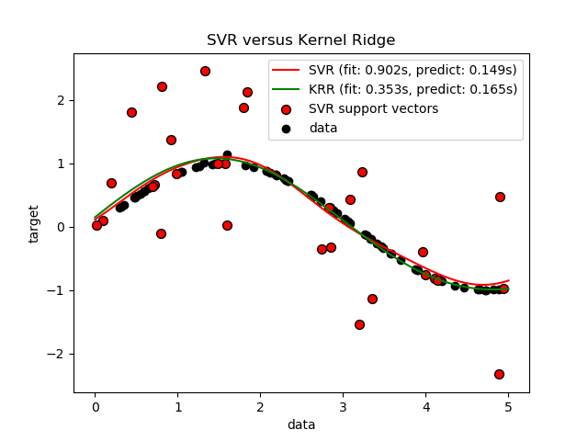](http://scikit-learn.org/stable/auto_examples/plot_kernel_ridge_regression.html)

The next figure compares the time for fitting and prediction of [**KernelRidge**](http://scikit-learn.org/stable/modules/generated/sklearn.kernel_ridge.KernelRidge.html#sklearn.kernel_ridge.KernelRidge) and **SVR** for different sizes of the training set. Fitting [**KernelRidge**](http://scikit-learn.org/stable/modules/generated/sklearn.kernel_ridge.KernelRidge.html#sklearn.kernel_ridge.KernelRidge) is faster than **SVR** for medium-sized training sets (less than 1000 samples); however, for larger training sets **SVR** scales better. With regard to prediction time, **SVR** is faster than [**KernelRidge**](http://scikit-learn.org/stable/modules/generated/sklearn.kernel_ridge.KernelRidge.html#sklearn.kernel_ridge.KernelRidge) for all sizes of the training set because of the learned sparse solution. Note that the degree of sparsity and thus the prediction time depends on the parameters \epsilon and C of the **SVR**; \epsilon = 0 would correspond to a dense model.

[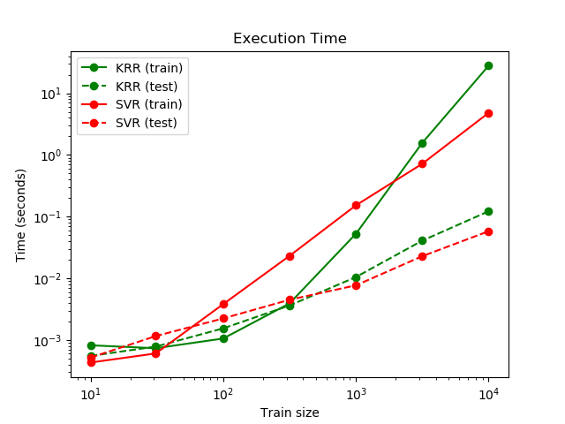](http://scikit-learn.org/stable/auto_examples/plot_kernel_ridge_regression.html)